REDLINE
Medical Supplies & Equipment Trading
ريد لاين للتجارة في المستلزمات والمعدات الطبية

Gap Analysis and Workflow Documentation (GAWF)
تحليل الفجوات وتوثيق سير العمل
Simulated legacy/manual processes versus proposed Odoo processes

Project | Odoo ERP Implementation - Graduation Project (simulation)
Document code | RL-GAWF-001
Version | 1.0 (final)
Preparation date | 25 October 2026
Business reporting period | 1 May 2026 – 30 September 2026
Target platform | Odoo 19.0 (Enterprise edition assumed)
Prepared by | Mohamed Mahmoud Abdel Bary, Mohamed Essam El-Din Youssef, Ahmed Mahmoud Mohamed, Fathy Adel Fathy, Omnia Haitham
Currency | EGP - Egyptian Pound
Disclaimer: all companies, partners, bank details and transactions in this project are fictional or illustrative simulation data. Nothing in this document claims that the configuration has been installed, imported or tested on a live Odoo server.

Contents
1 | Definition and method
2 | Baseline: simulated legacy / manual processes
3 | Workflow comparison
4 | Gap register
5 | Gap summary
6 | Validation plan
7 | Conclusions
Section numbers are used for cross-references throughout the document set (e.g. 'SSD 4.2' = Solution Design Document, section 4.2).

1. Definition and method
GAWF means Gap Analysis and Workflow documentation for this project. It compares the simulated legacy/manual process baseline of RedLine with the proposed Odoo process and, for each gap, states the solution, the standard Odoo capability, the configuration, any customization, priority, owner and validation method.
Basis. The baseline is a simulated manual process description. No real legacy software platform is named or assumed. Gaps are validated by design review and simulated data; none has been validated on a live Odoo server.

Method: (1) describe the as-is process with its owners; (2) describe the to-be process in Odoo; (3) classify each difference as a gap; (4) link every gap to requirements (BRD) and test cases (UATD); (5) rate priority (High = needed for go-live, Medium = needed within 3 months, Low = optional).

2. Baseline: simulated legacy / manual processes
Area | Baseline description | Evidence in simulation
Stock records | Stock cards and spreadsheets per warehouse; counted quarterly | 548 stock moves in 5 months to be captured system-side
Lots and expiry | Expiry written on cartons; no lot register | 42 lots/batches; 1 expiry-tracked lots now at period end within 60 days
Serials | Serial numbers on paper delivery notes | 186 serial units
Receivables | Spreadsheet balances; manual reminders | EGP 29,532,073 outstanding at 30-Sep-2026
Returns | Informal handling | 9 customer returns, 2 supplier returns, 8 scrap events

3. Workflow comparison
Process | As-is (manual) | To-be (Odoo) | Key difference
Procure-to-Pay | Email RFQ -> spreadsheet PO -> paper GRN -> typed bill -> manual payment list | Reordering rule -> RFQ -> approved PO -> receipt (lot/serial/expiry) -> QC -> matched bill -> payment reconciliation | Controlled, traceable and matched
Order-to-Cash | Quote in Excel -> paper delivery -> typed invoice -> spreadsheet collection | Pricelist quote -> credit check -> reserved FEFO delivery -> invoice -> payment matching | Automatic, credit-controlled
Receipt & putaway | Goods placed on shelves | Input -> check -> Stock/Quarantine | Failed goods isolated
Transfers | Verbal | Internal transfer with validation | No double counting
Returns & quarantine | Back on shelf or discarded | QRT with disposition and credit/debit note | Safe and accounted
Period close | Quarterly count; late adjustments | Monthly valuation-to-GL reconciliation, AR/AP control | Continuous reconciliation

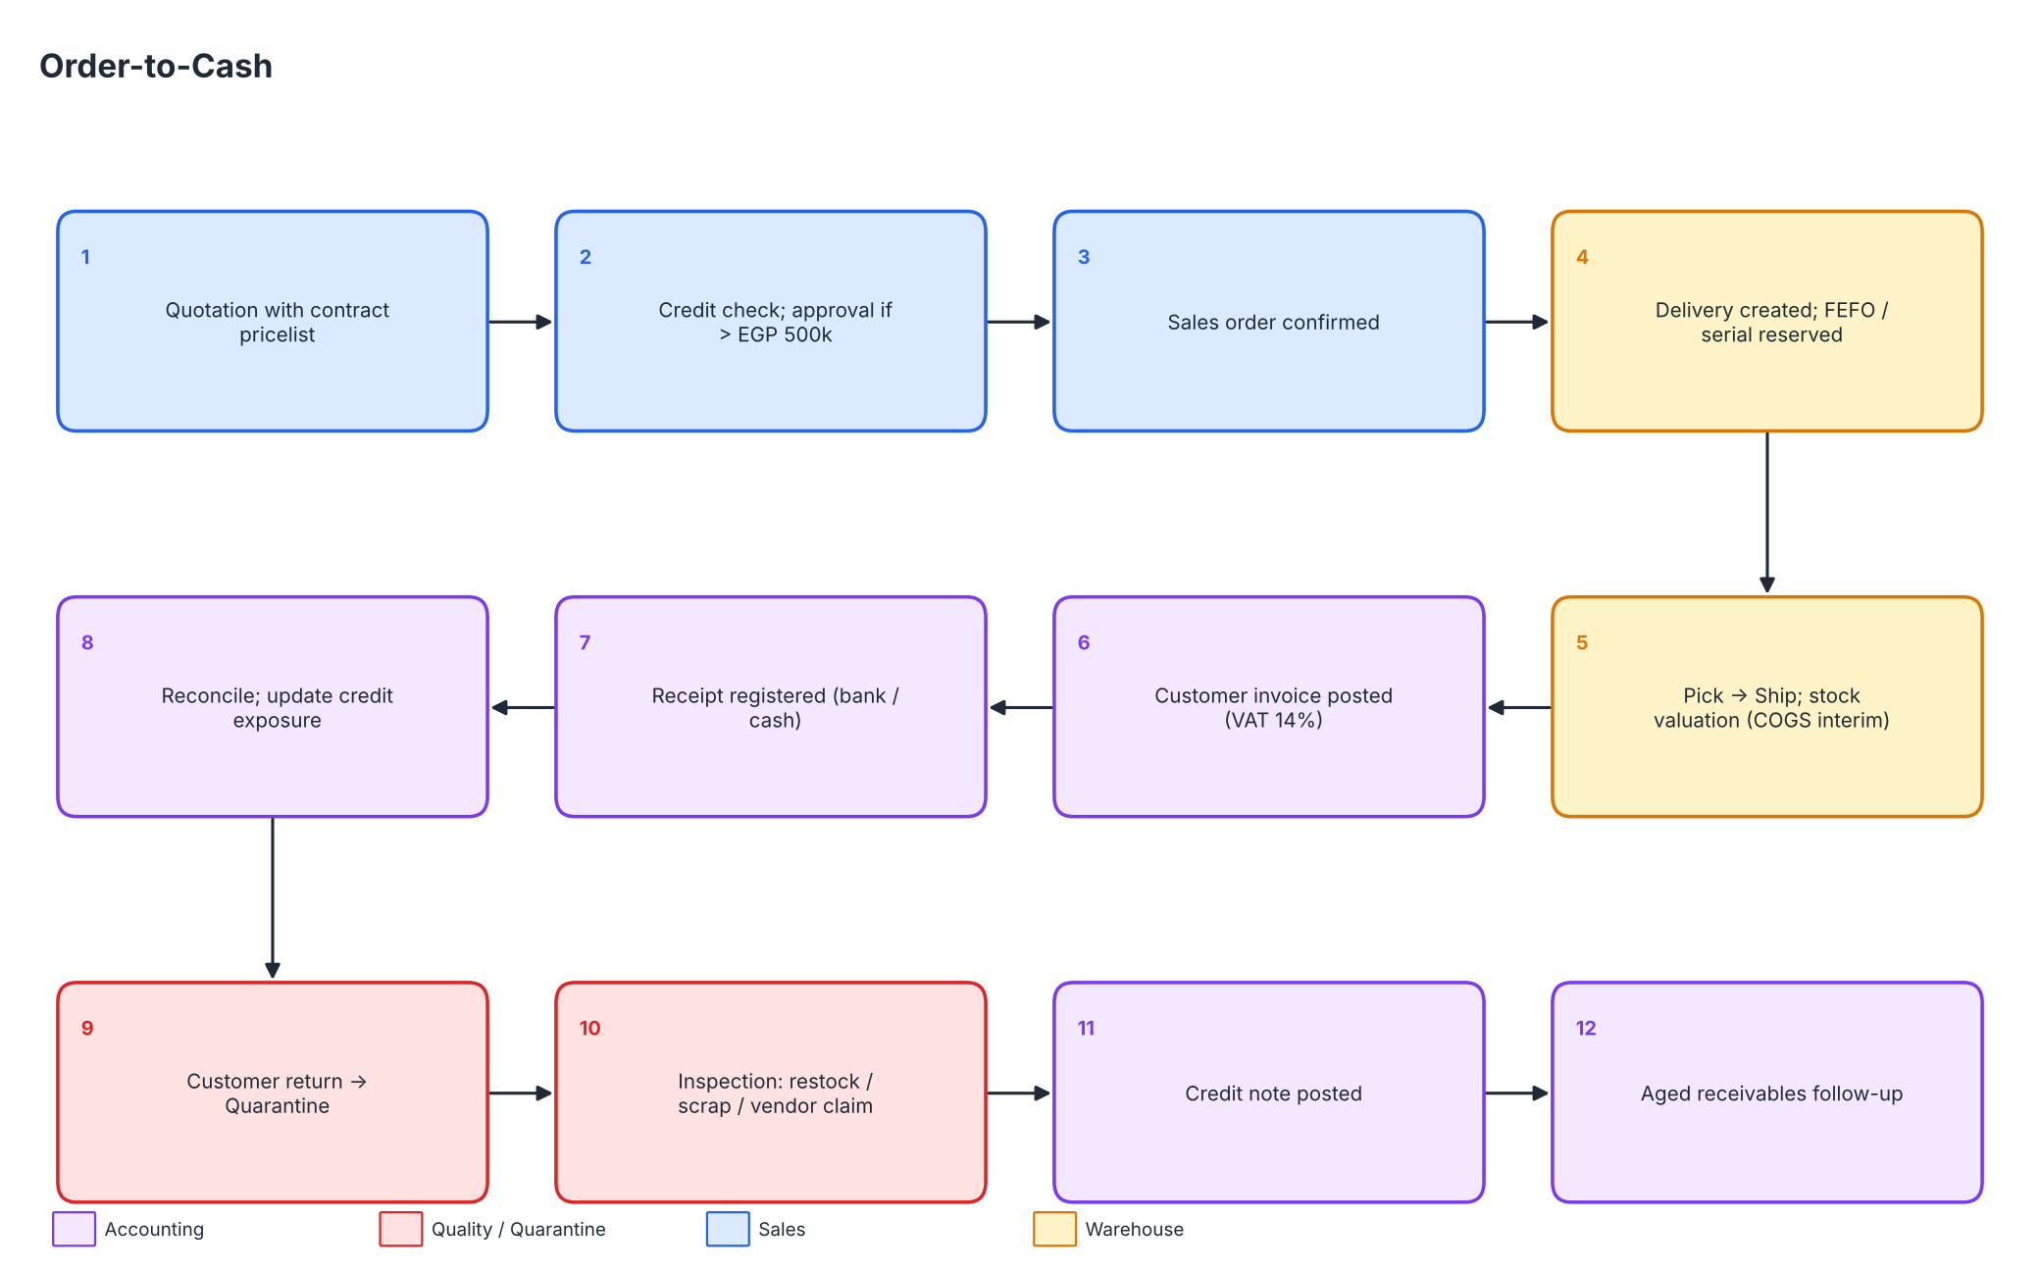
Figure - Order-to-Cash (to-be)
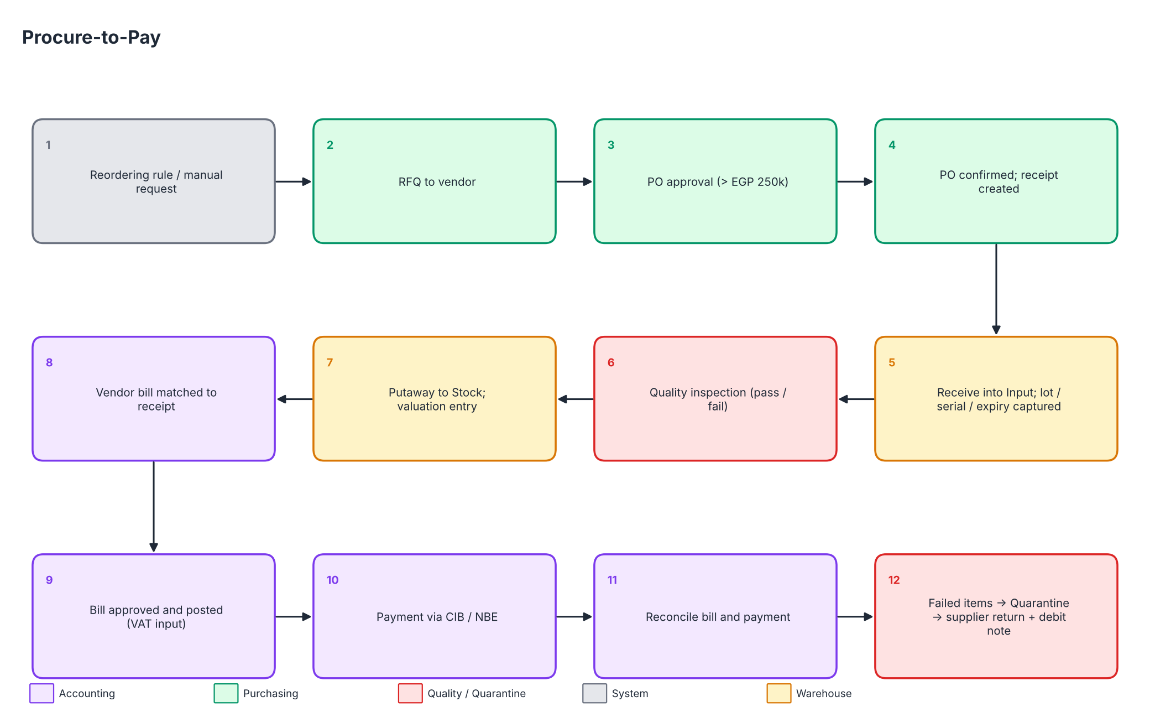
Figure - Procure-to-Pay (to-be)

4. Gap register
Gap ID | Process | Existing process | Required process | Business impact | Proposed solution | Standard Odoo capability | Configuration requirement | Customization | Priority | Owner | Validation method (requirements -> UATD)
G-01 | Quotation | Excel/Word quotations with manual price lookup | Pricelist-based quotation with contract discount and VAT | Price errors, inconsistent discounts | Sales module with customer pricelists | Quotations, pricelists, discounts | Pricelists per customer discount tier (0/2/3/5%) | None | High | Mohamed Essam El-Din Youssef | SAL-001, SAL-006
G-02 | Quotation | Approval by email/phone | Approval for quotations above EGP 500,000 | Uncontrolled large discounts | Approval rule on quotation confirmation | Sales approval (basic) / Studio approval (Enterprise) | Threshold setting; approver group | Studio automation or custom module (proposed) | Medium | Mohamed Mahmoud Abdel Bary | SAL-002
G-03 | Credit | Balances kept in spreadsheet, checked ad hoc | Automatic credit-limit check at order confirmation | Over-exposure to slow-paying hospitals | Credit limit per partner with warning | Credit limit warning on sales orders | Set limits (130% of peak exposure) and terms | Hard block / override approval (proposed) | High | Omnia Haitham | CON-004, ACC-009
G-04 | Master data | Duplicate customers across branches | Single partner master with classification and branch | Duplicate balances, wrong statements | Contacts with duplicate warning and tags | Contacts, tags, tax-ID check | Classification tags; duplicate rule | None | Medium | Ahmed Mahmoud Mohamed | CON-001, CON-003
G-05 | Order-to-cash | Paper delivery notes per warehouse | Order confirmation creates reserved delivery per warehouse | Delays, mismatches between order and delivery | Sales-to-inventory automation | Delivery orders, routes | Warehouses with home-warehouse routing | None | High | Mohamed Essam El-Din Youssef | SAL-003, INV-014
G-06 | Order-to-cash | Whole order or nothing; partials handled manually | Partial delivery with backorder and delivered-quantity invoicing | Late or wrong invoices | Backorder policy; invoice on delivered | Backorders, invoicing policy | Invoicing policy 'delivered quantities' | None | High | Mohamed Essam El-Din Youssef | SAL-004
G-07 | Procurement | Email RFQs; spreadsheet POs | RFQ-to-PO flow with lead times and approvals | No approval trail; late replenishment | Purchase module with double validation | RFQ, PO, vendor pricelists, lead times | Approval above EGP 250,000 | None | High | Fathy Adel Fathy | PUR-001, PUR-002
G-08 | Replenishment | Reorder decided by memory | Min/max reordering rules with scheduler | Stock-outs of fast movers (e.g. infusion pumps, cannulas) | Reordering rules per product/warehouse | Replenishment, scheduler | 23 rules from Products workbook | None | High | Fathy Adel Fathy | PUR-003, INV-012
G-09 | Receiving | Paper GRN; lots/expiry not captured | Mandatory lot/serial and expiry at receipt | No traceability; expired stock sold | Lots, serials and expiration dates enabled | Lots & serial numbers, expiration dates | Tracking per product; expiry alert 60 days | None | High | Ahmed Mahmoud Mohamed | PUR-007, INV-003, INV-004, INV-005
G-10 | Inspection | Informal visual check | Documented quality check with failure routing | Defective goods enter stock | Quality control point on receipts | Quality app (Enterprise) | Control point on receipt operation types | Manual checklist if Quality app unavailable | High | Fathy Adel Fathy | INV-002
G-11 | Storage | Single shelf list; no location logic | Input/Stock/Output and per-warehouse locations | Wrong picking, no putaway discipline | Multi-step routes and putaway rules | Storage locations, routes | EQP/CON 2-step; SPR 1-step | None | Medium | Ahmed Mahmoud Mohamed | INV-001, INV-014
G-12 | Picking | FIFO by habit; no expiry logic | FEFO for consumables | Expired and near-expiry write-offs | FEFO removal strategy | Removal strategies | Category-level FEFO | None | High | Ahmed Mahmoud Mohamed | INV-006, INV-007
G-13 | Transfers | Verbal transfers | Documented internal transfers | Double counting/loss between warehouses | Internal transfer operations | Internal transfers, in-transit | Operation types per warehouse | None | Medium | Ahmed Mahmoud Mohamed | INV-008
G-14 | Quarantine | Returned/damaged goods put back on shelf | Quarantine warehouse excluded from sale | Risk of selling failed/returned goods | QRT warehouse and flows | Locations, routes, scrap | QRT non-sellable; dispositions | None | High | Fathy Adel Fathy | INV-009, INV-010, SAL-008
G-15 | Returns | No link between returns and invoices | Return linked to invoice with credit note | Overstated revenue, disputes | Return/credit note flow | Returns, credit notes | Credit-note journal; reason codes | None | High | Mohamed Essam El-Din Youssef | SAL-008, ACC-004, PUR-005
G-16 | Traceability | Serials in paper registers | Upstream/downstream trace for lots and serials | Slow, incomplete recalls | Traceability report | Lot/serial traceability | Tracking on all medical products | Recall communication manual | High | Ahmed Mahmoud Mohamed | INV-013
G-17 | Warranty | Warranty dates in a notebook | Warranty end date per serial | Missed warranty claims, disputes | Warranty months on product; end date per serial | Not standard | Custom field + report | Custom module/Studio (proposed) | Medium | Mohamed Essam El-Din Youssef | SAL-007
G-18 | Invoicing | Invoices typed after delivery | Invoice from delivery with VAT and branch | Delayed billing and errors | Invoicing from sales order | Invoices, taxes, analytic | VAT 14% (assumption), branch analytic | None | High | Omnia Haitham | ACC-001, ACC-006, SAL-005
G-19 | Collections | Manual follow-up of due dates | Ageing report and payment reconciliation | Slow collection from 45-60 day customers | Aged receivable; payment matching | Payments, reconciliation | Bank/cash journals, payment methods | Statement import (Enterprise) | High | Omnia Haitham | ACC-003, ACC-009, ACC-011
G-20 | Valuation | Quarterly count; ledger adjusted late | Perpetual FIFO valuation and COGS | Margin unknown until quarter-end | Automated valuation, Anglo-Saxon | Stock accounting | Category accounts 1301xx/4101xx/5101xx | None | High | Omnia Haitham | ACC-005, INV-017, ACC-012
G-21 | Chart of accounts | Ad hoc accounts, no inventory split | Structured 101-account chart with stock, loss and VAT accounts | Poor visibility of losses and margins | Proposed company-specific chart | Accounts, groups, journals | Import CSV 08/09 | Accountant review needed | High | Omnia Haitham | ACC-010, MIG-001
G-22 | Branch reporting | Branch results compiled in Excel | P&L and sales by branch | Late, inconsistent branch view | Analytic plan Branch (or branch records) | Analytic accounting | Plan, defaults on documents | Branch record rules (proposed) | Medium | Mohamed Mahmoud Abdel Bary | ACC-007, SAL-005, RPT-001, SEC-002
G-23 | Approvals & audit | No audit trail | Tracked changes and segregation of duties | Fraud/error risk | Tracking, groups, approval rules | Chatter tracking, groups | Tracked fields; group matrix | Segregation rules (proposed) | High | Mohamed Mahmoud Abdel Bary | SEC-001, SEC-003, SEC-004
G-24 | Reporting | Reports built manually in Excel | Management KPI dashboard | Slow decisions | Dashboards | Spreadsheet dashboards (Enterprise) | KPI list from BRD 11 | Optional dashboard design | Medium | Mohamed Essam El-Din Youssef | RPT-002, RPT-003
G-25 | Localization | English-only or ad hoc Arabic documents | Arabic/English with RTL printing | Unprofessional or unreadable documents | Language packs and report fonts | Languages, QWeb reports | Arabic fonts; layout test | Report template tuning | Medium | Mohamed Mahmoud Abdel Bary | NFR-001, NFR-002
G-26 | Continuity | Local spreadsheets on PCs | Daily backups and restore test | Data loss | Backup procedure | Hosting-provider backups | Retention policy | Manual procedure | High | Ahmed Mahmoud Mohamed | SEC-005
G-27 | Migration | Data scattered in files | Cleansed, validated, reconciled loads | Wrong opening data | Import package and validation | Import tool | Import order and checks | Scripted history load (proposed) | High | Ahmed Mahmoud Mohamed | MIG-001..MIG-005
G-28 | Lead-to-opportunity | Leads kept in personal contact lists and email | CRM pipeline with stages, sales teams and activities | Lost leads, no forecast, no win-rate visibility | CRM app with pipeline, activities and sales teams | CRM leads, opportunities, activities, pipeline report | Stages, teams per branch, lost reasons, lead sources | None | High | Mohamed Essam El-Din Youssef | CRM-001..CRM-007
G-29 | Tender tracking | Tender deadlines tracked in a spreadsheet | Tender reference, deadline and bid bond on opportunity | Missed tender deadlines | Opportunity tags and standard fields | Tags and activities (standard); custom fields (proposed) | Tender tag; reminder activities | Custom fields for tender reference/deadline/bid bond (proposed) | Medium | Mohamed Essam El-Din Youssef | CRM-008

5. Gap summary
Metric | Value
Total gaps | 29
High priority | 20
Medium priority | 9
Low priority | 0
Gaps needing customization, Enterprise feature or accountant review (proposed) | 12

Owner | Gaps owned
Mohamed Essam El-Din Youssef | 8
Mohamed Mahmoud Abdel Bary | 4
Omnia Haitham | 5
Ahmed Mahmoud Mohamed | 8
Fathy Adel Fathy | 4

6. Validation plan
- Each gap's validation methods reference BRD requirement IDs; each requirement has a test case in UATD_User_Acceptance_Testing.xlsx.
- Design review by Mohamed Mahmoud Abdel Bary; accounting gaps (G-18 to G-21) by Omnia Haitham; data-driven checks by Ahmed Mahmoud Mohamed (reconciliations in the three data workbooks).
- Live-Odoo validation is outstanding for gaps relying on Enterprise features or customizations: G-02, G-03, G-10, G-17, G-19 (statement import), G-22, G-23, G-24.

7. Conclusions
The gap analysis shows that most gaps close with standard Odoo features and configuration. The remaining items - hard credit blocking, warranty tracking, branch-based access rules, approval chains and dashboards - are proposed customizations or Enterprise features and are carried into the Technical Proposal (TPD 6) as proposed work, not completed implementation.

